**UNIVERSITY OF WESTMINSTER**

12

**Semester 2-CourseWork1**

**Module Enrollment**

**Edoardo Foco w1266346**

Activity Diagram

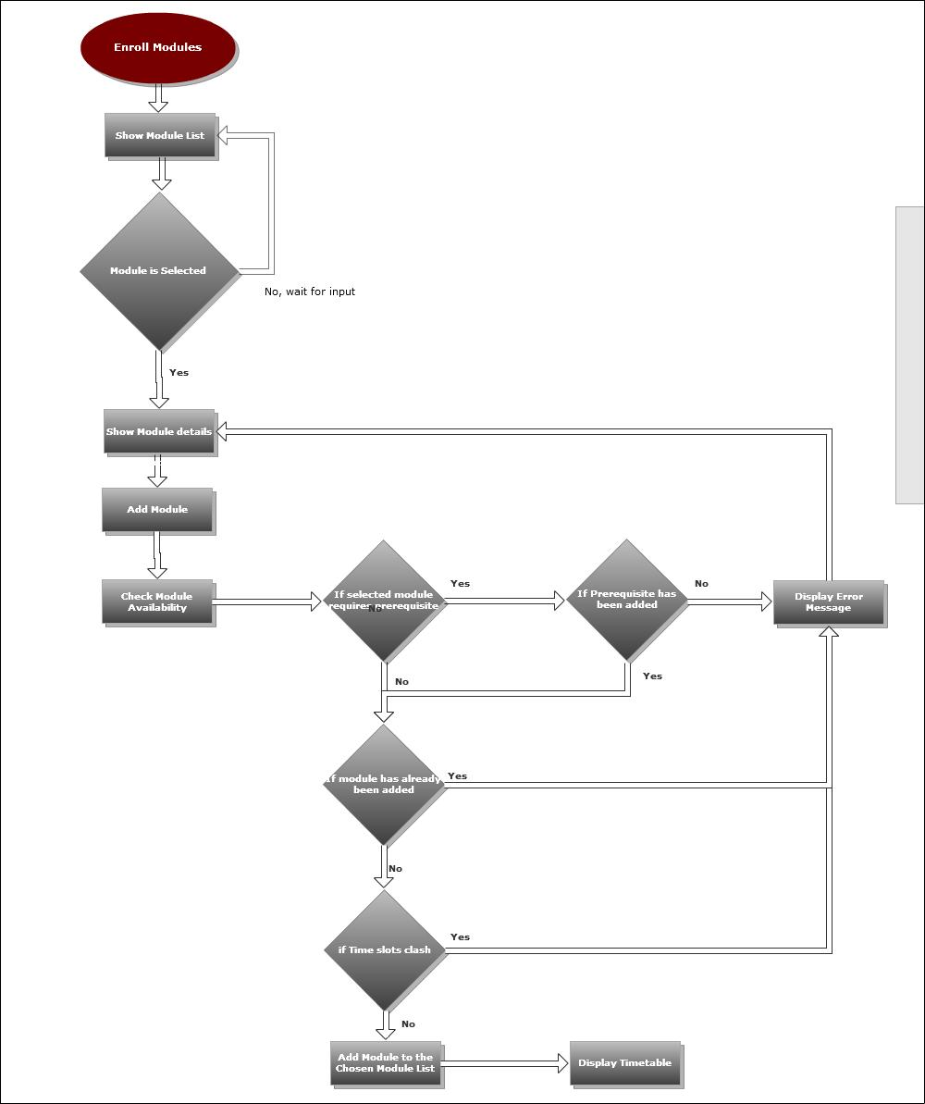

Class Diagram

